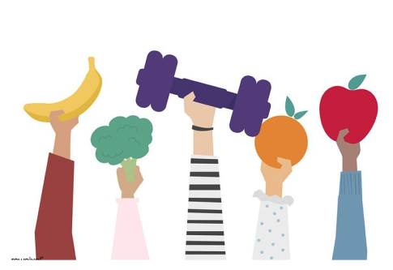

# UI/UX case study: Designing a weight loss Mobile App

Aiming to help people to lose weight easily

Mohammed Elzanaty

8 Sep 2021

Designed with Figma, Miro, Zeplin, lookback

# The Challenge

Nowadays, people are either busy or lack the knowledge to care about their meals' nutrition. It is essential to be aware of what you eat daily.

Weight loss and a healthy lifestyle have been a hot topic; there are always so many websites and applications, so many bloggers and influencers introducing and advertising diet plans, weight loss applications, and nutritionists in social media.

The question is, how many people are confident with the result and how many people spent lots of money and got disappointed in the middle of the way.

Therefore, We have decided to help them by creating a mobile app for those who desire to lose weight by calorie counting diet method and need a bit of motivation and ease.

# Current Solutions

Before starting my solution, I found some weight loss applications related to my project. One app that my users also mentioned the name and added in my research plan (MyFittnessPal) almost answers the problem. But most apps either non-user-friendly or challenging to bring the user's needs.

# My design Process

I have followed this process to make sure my design decisions were supported by user research and feedback.

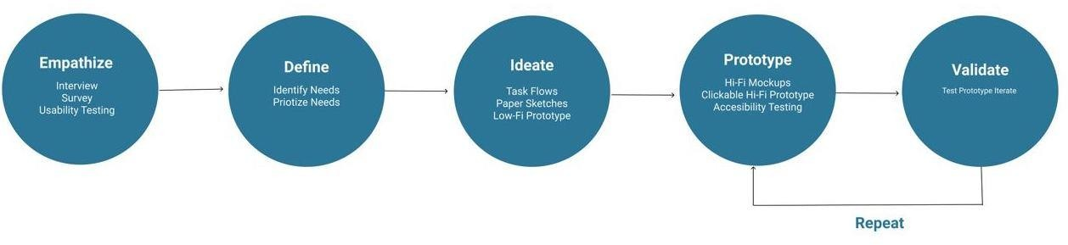

# Research Methods and Findings

Before starting the process, I created Interview questions which gave me an idea of users need. I gathered information about the concept, end-users, problems my product is trying to solve, current solutions, competitors.

Then I found five women for interview. They were of different ages, but they were all employed and had similar time management problems to have a healthy lifestyle.

Based on key findings, I realized that the users are willing to track their daily calories; however, the current solutions are not motivating enough, and stop inspired after a while. So they need something user friendly and comfortable enough to interact with which covering their needs, including

* Information regarding nutrition and macro counting
* Track weight loss excels chart.
* Invite and follow friends to stay motivated.

While these are small numbers of data, it was more than enough for me and my little personal project.

# Digital Affinity Diagram

This diagram is my digital affinity map. I summarized and scripted all the notes and created an affinity Diagram using Miro which helped me to get full picture of my design and product features.

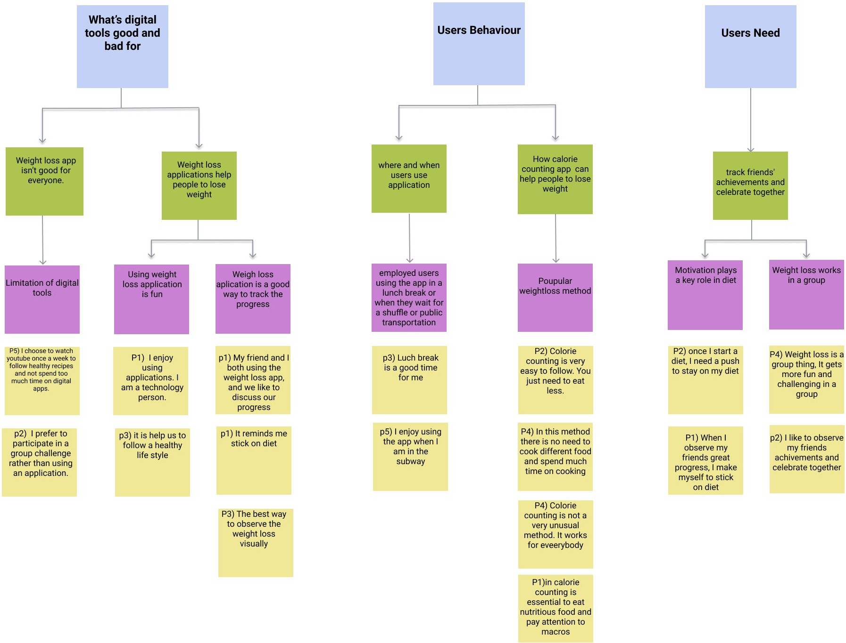

# Research synthesis

I summarized all the notes from users' pain points and the needs into similar categories and created a single board contains all the information from users.

I selected and prioritized the most and least essential features for users and the application after that.

For the next step, I formed the principal **features** of my app, including:

* + Pain Point 1 : Registration and login
  + Pain Point 2: Set initial goal
  + Pain Point 3 : Database of ingredients calorie
  + Pain Point 4 : Set nutritional goal
  + Pain Point 5 :Observe the process

# Identifying Pain Points

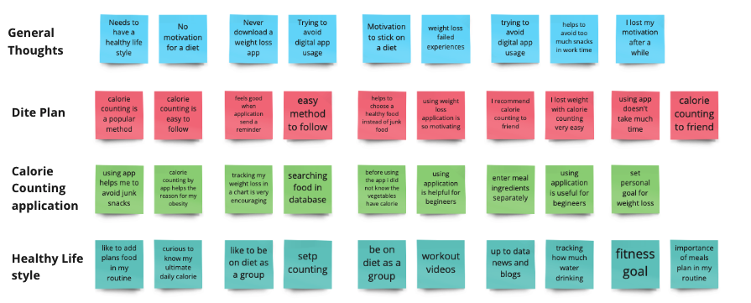

I summarized all the notes from users' pain points and the needs into similar categories and created a single board contains all the information from users. I selected and prioritized the most and least essential features for users and the application after that.

# Prioritizing Pain Points

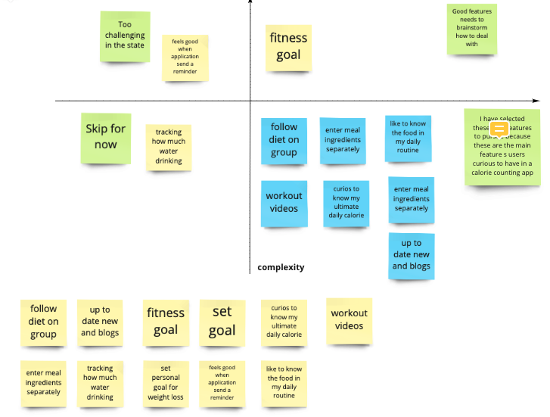

For the next step, I created a Prioritization Matrix, which is a table that lets you rank ideas in order of importance of features for development.

I have weighted each feature's in this project, and as a result, I formed the principal **focus** of my app, including:

* + - Pain Point 1 : Registration and login
    - Pain Point 2: Set initial goal
    - Pain Point 3 : Database of ingredients calorie
    - Pain Point 4 : Set nutritional goal
    - Pain Point 5 : Observe the process

# Task Flow (Based on Usability Study)

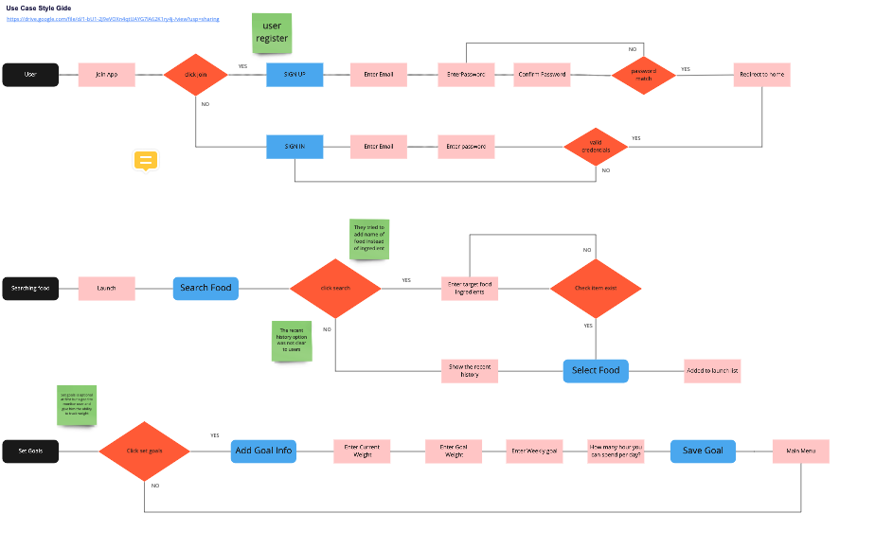Next, I created a usability test; this helped me understand what and how users can interact with the product interface, find the difficulties, and develop the second iteration of the low-fi sketch.

After defining user goals, I started with existing tasks, gave my users one task at a time, and followed the design flow. I analyzed their problem in a test.

Based on my usability test, I figured out most users had no problem creating an account, 3 out of 5 users had difficulty setting the initial and nutrition. Almost no one could pass the surfing the database step in the first iteration.

# Ideate & Sketch

After conducting validation tests, I started rapid sketching for the first sketch of interface design for the ideation process. This helped me with quick experimentation. In my case was a crazy-8s method paper sketch, which means it needs an A4 sheet of paper draw eight boxes on it in a timer set for eight minutes. In a paper sketch, I mapped out the journey to find the best specific way and narrowed down to two realistic ideas.

Along with that, I started a low-fi design using Figma. I personally enjoy working on low-fi as much as possible it takes because I believe that low-fi prototypes are the design's skeleton view. It is very important to get it done correctly before starting on the central part of the design.

For this project, the low-fi prototype comes in two iterations. The first iteration was made before the usability test, and the second iteration came up after the usability test. It got fixed based on users' needs.

# Paper Sketch & Low-Fi Design

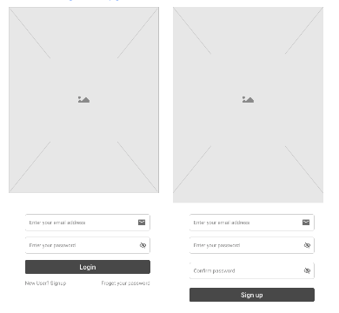

Paper Sketch

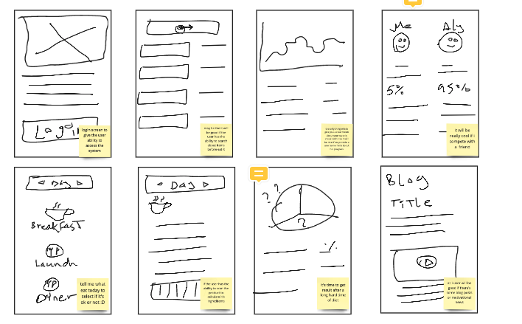Iteration 1

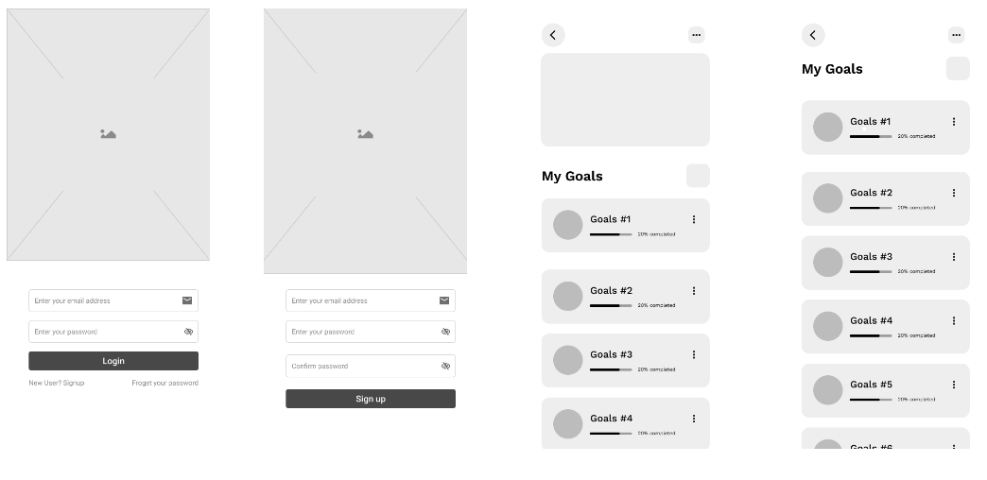Iteration 2

# Color Palette

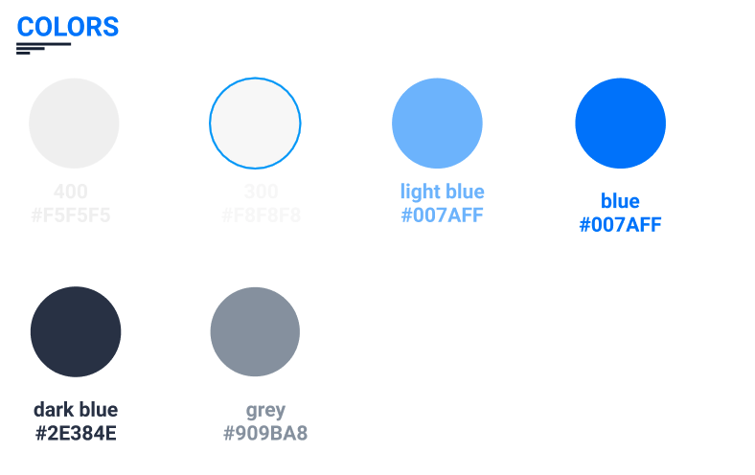The color blue is the ocean's color and the sky; it symbolizes serenity, stability, inspiration, or wisdom. It can be a calming color and represent reliability.

So I decided to use a blue color pallet with some highlights in green, and I used black and white for text and complementary and clean appearance.

# Typography & Icons

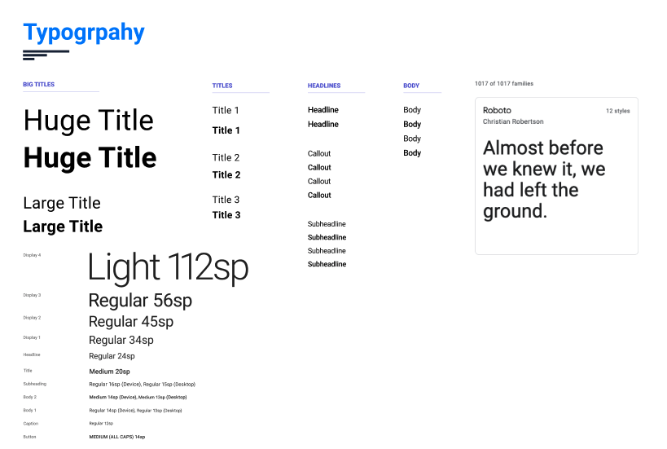

As typography, I have used which is Montserrat is a free google font. It is part of the sans serif typeface superfamily. As a pairing font, I have chosen Roboto.

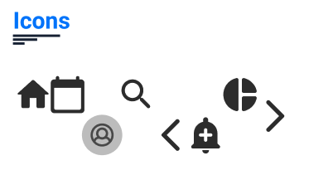

Icons and illustrations always are an essential part of UI design. Icons should be meaningful, characteristic, and consistent; it should be compatible with the concept.

# Prototyping

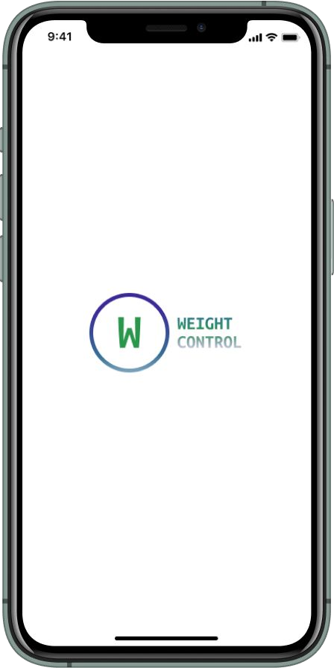After finished up paper sketches and Low-Fi prototype, I started to create a High-Fi prototype of my proposed solution to illustrate my ideas and represent the concept for getting quick feedback and improving the product.

My Hi-Fi prototype was created with Figma and consists of 15 frames and focused on users' pain points.

Also, I have used Zeplin to export my prototype file to generate development resources.

# Validation

After creating the clickable Hi-Fi prototype, I conducted a user testing to validate my ideas and the user interface usability. It was tested on 10 users through lookback platform.

## Chosen tasks for the test:

* Create an account /Login with your account
* Set up goal state for the first time after registration.
* Diary page to enter food ingredients in the database.
* Search for food in the database page.
* Set a goal page.
* Observe progress.

## Guided Questions for users:

1- What do you think about color combination? Is it visually pleasing? 2- What do you think about the size and shape of buttons?

3- How easy can you interact in the app? 4- What is one thing to improve the app?

5- What is one thing you like the most about the app? 6- What is one thing you don’t like about the app?

# Usability Feedback

After conducting a validation test, this result came up:

## Things have done well:

* Color combination, icons, buttons shape are good.
* The app sounds neat to users and they like the design.
* The registration seems easy to them.
* Most of the features are understandable.
* Cool to have set up a goal in the first place.

## Things need to have improvement:

* The iphone frame is disturbing on mobile devices.
* The homepage needs extra information.
* Search for food in the database page needs more improvement, It needs to be clear enough for everyone.

All the points mentioned by users which needed to have improvement already improved in the current version.

75%

25%

# About Me

I am Mohammed Elzanaty, A Software Engineer who is passionate about UI/UX Design. I have M.Sc. in Computer Engineering from the University of Ottawa. Along with a minor degree in User experience and User Interface Design, I believe that my research understanding will help me further understand user needs to create a user experience design.